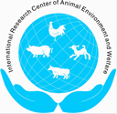 |  | 2023 International Symposium  On Animal Environment and Welfare  Chongqing, ChinaOctober 23–25, 2023 |  | 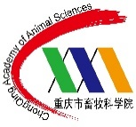

Abstract Submission Form (Due March 31, 2023)

Theme Area no. & Topic:
Paper/Poster title:
Author names:
Presentation Type: Oral Poster No preference
First author (if not Corresponding author) E-mail:
Corresponding author E-mail (req’d):
First Name: Surname: Title:
Institutional Affiliation:
Street Address:
City: State/Province:
Zip/Postal Code: Country: Phone:
Abstract (<250 words):

